**Lab 4.2**

***What happens when you input 60 as the average?***

The program ends without any further input/output. The mistake here is that the program is designed to have an output for an average either below or above 60, but not equal to it.

***Modify the first if statement so that the program will also print "You Pass" if the average equals 60. Take a screen shot of the output.***

I modified the statement. It now reads ">= 60" on the first if statement. So here's the output:

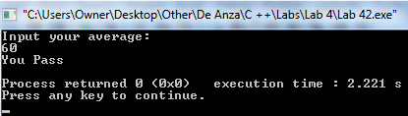

***Modify the program so that it uses an if/else statement rather than two if statements.***

I modified the program to have an if/else statement.

***Modify the revised program earlier to allow the following categories: Invalid data (data above 100), 'A' category (90-100), 'B' category (80-89), "You Pass" category (60-79), "You Fail" category (0-59). What will happen to your program if you enter a negative value such as -12?* Take a screen shot of the output. Insert it in LastFirst_lab42.doc.**

The program ends and it doesn't display any particular output if I enter -12. There was no indication on this lab to create a particular category for any value below 0). Here's the output:

